Use Case: Start Game

Step | User’s Action | System’s Response
1 | Player boot up the game
2 |  | GUI displays two options for the “look and feel” of the game
3 | Player clicks a button
4 |  | GUI displays a mancala board (without stones) with the selected “look and feel”, and an undo button
5 |  | GUI asks the player to enter the number of stones per pit (3 or 4)
6 | Player chooses an option
7 |  | The chosen amount of stones are added to each pit
8 |  | Go to Make Move step 1

Use Case: Make Move

Step | User’s Action | System’s Response
1 | Player chooses to Make Move (clicks on a pit on their side)
2 |  | The selected pit’s stones are distributed one by one to each pit (and their mancala) in a counter-clockwise direction.
3 |  | The last stone is dropped in their mancala
4 |  | Player is asked to Undo or Make Move
5 | Player Makes Move
6 |  | Repeat from step 2

Variation #1

1.1. Start at step 2.
1.2. The last stone is dropped in an empty pit on their side.
1.3. All stones in the mirrored pit are removed and placed in the current player’s mancala.
1.4 Player is asked to Undo or the next player can make a move.

Variation #2

2.1. Start at step 2.
2.2. The last stone is dropped in a pit on the opponent’s side, or a non-empty pit on their side.
2.3 Player is asked to Undo or the next player can make a move.

Variation #3
1.1. Start at step 2.
1.2. One of the sides is empty of stones.
1.3. Stones on the other side are put into that player’s mancala.
1.4. Whoever’s mancala has more stones is declared the winner.
1.5. System exits.

Use Case: Undo

Step | User’s Action | System’s Response
1 | Player clicks on the Undo button
2 |  | The board’s state is returned to its state before the last move.
3 |  | Go to “Make Move” step 1

Variation #1

1.1. Start at step 1.
1.2. The player has chosen to Undo for a third time on their turn.
1.3. Undo is no longer available to the player this turn.

CRC card:

Model

Get the initial layout

Get the amount of stones

Decide the moves

Handle undos

VIEW
Setup the preference

Display the board
Handle the current board STATECHANGE

LISTENER
Mouse listener to fill the board MARBLES

Get the mouse ID

MARBLES
Draw the marbles icon

BoardLayout Interface
Handle marbles

Icon board

UML Class Diagram(Simple)
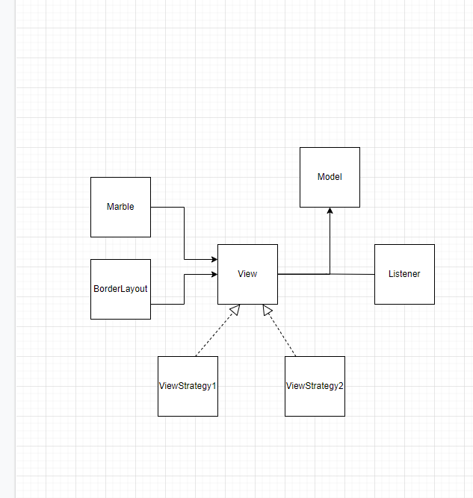

Sequence Diagram

